**MA Labor Economics – Problem Set 1 (Due Saturday 25th March)**

Omry Yoresh – ID: 20588769-8

**Part 1:**

1. Indicate whether the following statements are True/False/Uncertain and explain why. The explanation is the key part of your answer.
   1. “Tax credit systems are good for work incentives.”

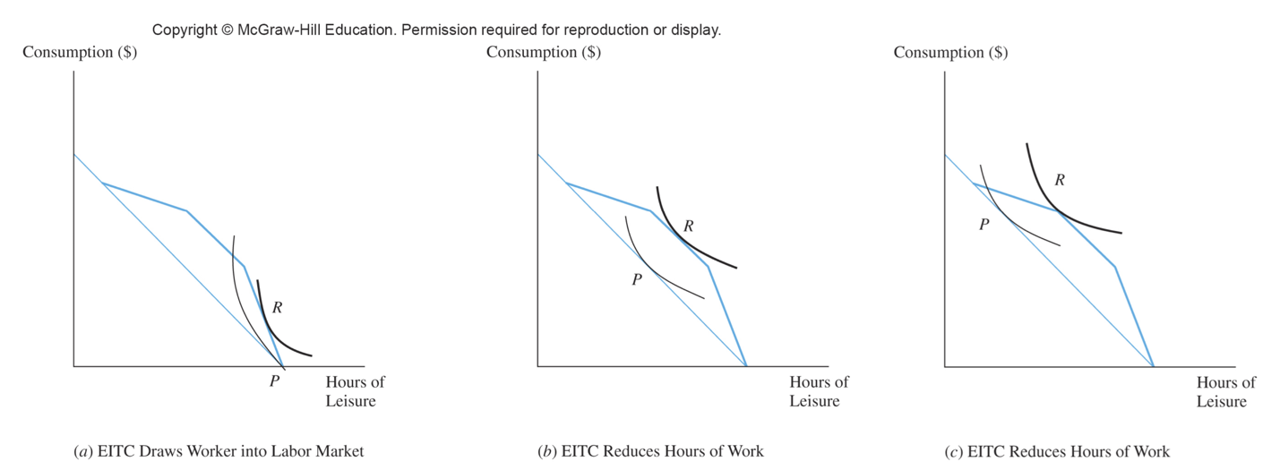Uncertain. The impact on work incentives may depend on several factors. While tax credit laws and reforms may increase labor supply in the intensive margin, by reducing the effective tax rate on earning, they might as well work in the opposite direction in the extensive margin. The reduce in hours of work in the extensive margin might occur when the income effect is dominated by the substitution effect. These effects might also vary also between individuals as it depends on the form of their utility function.

* 1. “The more persistent the shock to wages, the larger the labor supply response.”

False. As the wage shock becomes more persistent the labor supply response becomes smaller. As the wage shock is persistent the wealth effect will be larger and the effect will likely be driven by the Marshallian elasticity, where due to the increase of the wealth effect it weakens the substitution effect in play and thus drives down the labor supply effect.

* 1. “The impact of a pandemic on labor supply is likely to be very different to the impact of a business cycle downturn.”

True. While the impact of a pandemic on labor supply may differ in certain ways from the impact of a typical business cycle downturn, they are both considered transitory shocks and may therefore be viewed similarly in some respects. However, they have different underlying properties and therefore differ in effect on the labor supply. While a business cycle downturn typically effects the labor market through a decline in aggregate demand, pandemics can affect labor supply by disrupting supply chains, reducing the availability of workers due to illness or quarantine measures, and shutting down business due to social distancing. These distinctive routes of effect in the manner might lead to different outcome in the labor supply and although they are both transitory, the effects of a pandemic might lead to very persistant changes in the economy (e.g., work from home and more).

**Part 2:**

1. What are Farber’s criticisms of Camerer et al. (1997)?

Farber’s results show that in contrast to Camerer et. al’s (1997) results that in intertemporal labor supply context the daily income effects are small – meaning the decision to stop working at a particular day is related to the cumulative daily hours worked until that moment. Camerer et al. (1997) studied that exact setting, New York City cabdrivers, and found that the labor supply behavior can be interpreted as target earnings behavior, meaning large daily income effects. Therefore, as the findings contradict Farber raises several of criticisms of Camerer et. al’s (1997) paper.

First, as the empirical model goes, their model relies on there being a significant exogenous transitory day-to-day variation in average wages – where there is not. Second, this model doesn’t consider important facets of the taxi-drivers labor structure. Some important aspects are: (i) is the taxicab leased or own, (ii) how much time have they already been on the road when a change of hourly rate occurred and so forth. Third, recognized by the authors of both papers, is the division bias when the dependent variable is a product of division of the independent variable, which can lead to a *negative* bias of the estimate. Although Camerer et al. addressed this issue with an instrumental variable analysis, this was a weak variable and a there might as well be day-specific factors that effect both wage and hours.

1. What empirical model does Farber estimate? And why?

Farber estimates a model of a taxi driver’s labor supply as a survival time model, where the quitting can occur in discrete points in time which correspond to the end of fares. The reason is that with this specific form, the model can include that a driver can calculate the forward-looking expected optimal stopping point.

1. What are Farber’s main results?

After replicating Camerer et. al’s (1997) results, which show strong negative elasticities, the estimation of the probit optimal stopping model suggests that either hours or income, taken alone, are strong predictors of the likelihood of stopping work. When both sets of variables are included in the model, the hours effects remain strong, with a driver being 8.4 percentage points less likely to stop work after a trip ending in the sixth hour than after one ending in the eighth hour and 8.6 percentage points more likely to stop work after a trip ending in the eleventh hour than after one ending in the eighth hour.

These results show that the income effect is attenuated, particularly at the high end. A driver is 6.3 percentage points less likely to stop work after a trip ending with income of $50–$74 than after one ending with income of $150–$174. However, there is no significant difference in the probability of stopping after a fare with income greater than or equal to $225 relative to one ending with income of $150–$174.

1. What can we learn from this paper about the elasticity of labor supply?

First, we need to be cautious, both in results and in interpretation of labor supply. As we saw the results in Camerer et. al’s paper did not align with the theoretical model and the reasons for concerns were justified by what can drive this result. Another is that there are different properties for each profession, which makes the art of building an analysis difficult and lead to different interpretation of results.

1. What are the limitations of this paper?

This paper couldn’t estimate the elasticity of labor supply for taxicab drivers, as there is no exogenous permanent or transitory shift in the general level of earnings opportunities. Also, to create a complete analysis of labor supply response to changes in earning opportunities, there needs to be both daily hours responses and responses in the number of days worked, which will enable to examine the extensive margin.

1. How do the conclusions of Thakral and To (2021) differ from Camerer et al. (1997) and Farber (2005)?

The conclusion of Thakral and To (2021) differ from Camerer et al. (1997) and Farber (2005) in that it allows to examine each taxi driver’s labor supply behavior by a reference-dependent model. This modeling finds that drivers work less in response to higher accumulated income, while also finding a strong effect for recent earnings that gradually diminishes. These results which are based on the dynamic view of reference dependence reconcile the two contradicting finding discussed above.